1. QA Engineer Found Bugs, Create Bugs Issue

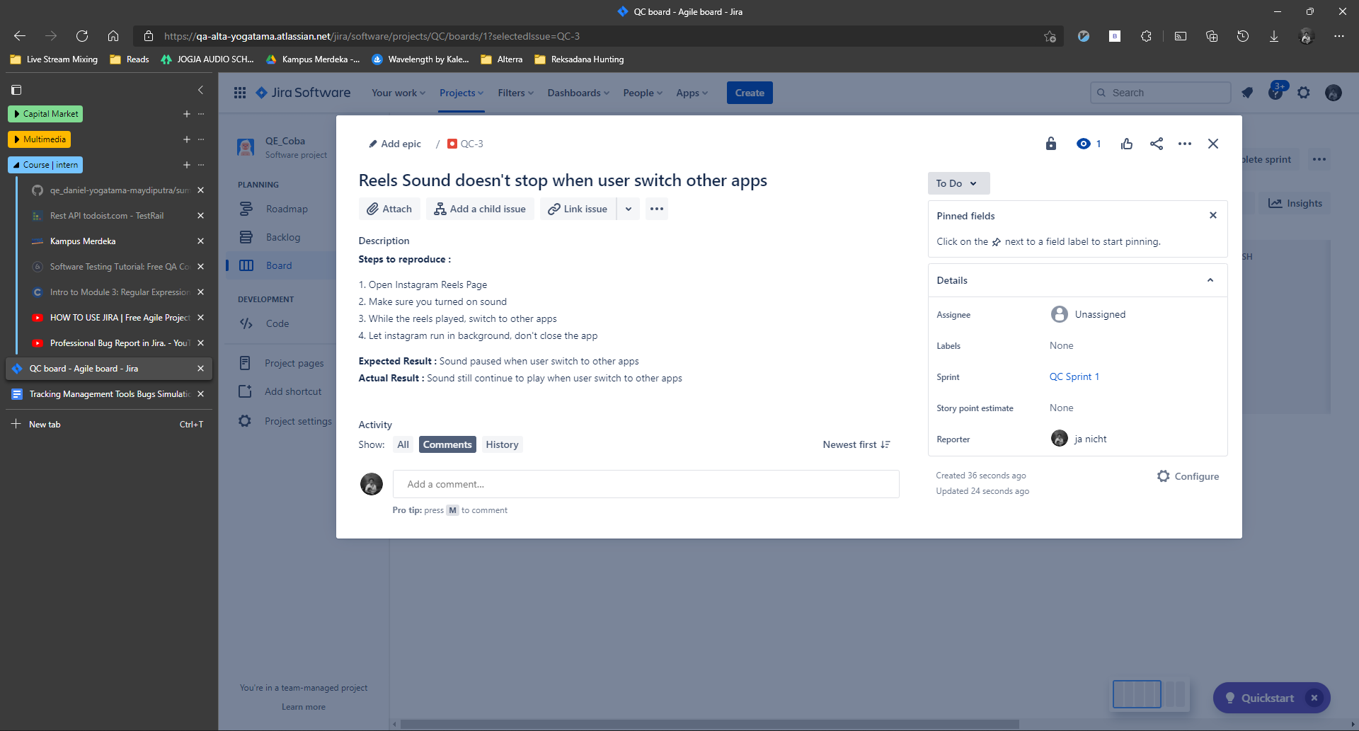

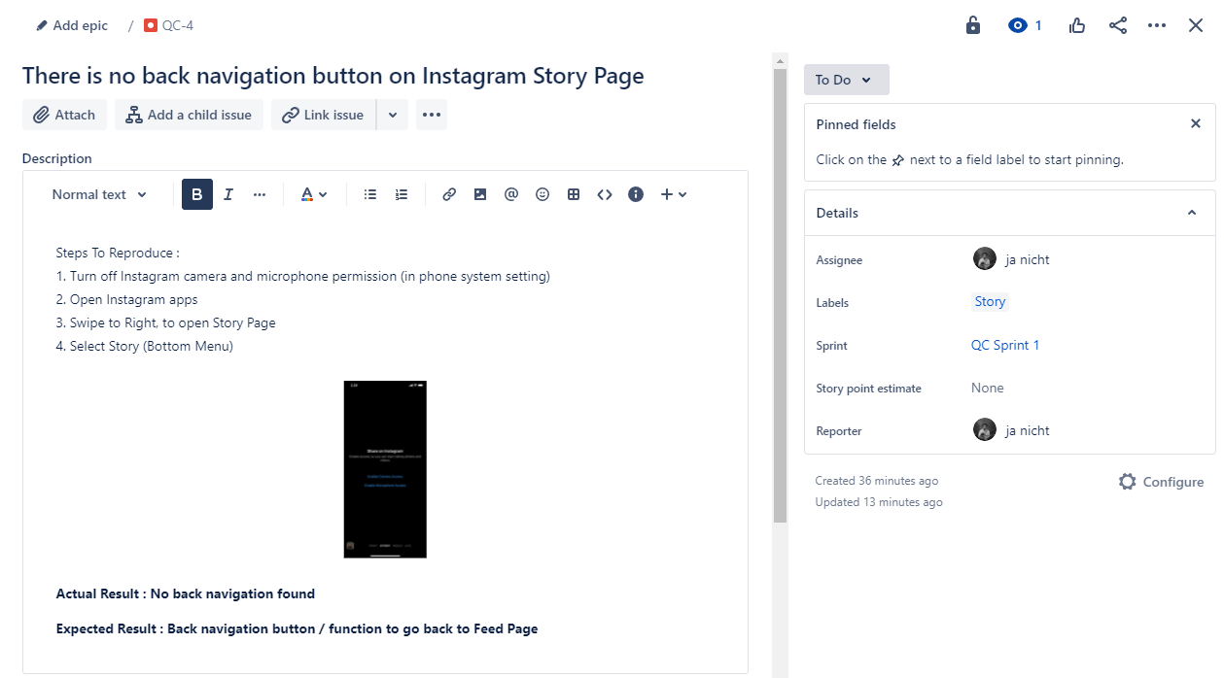

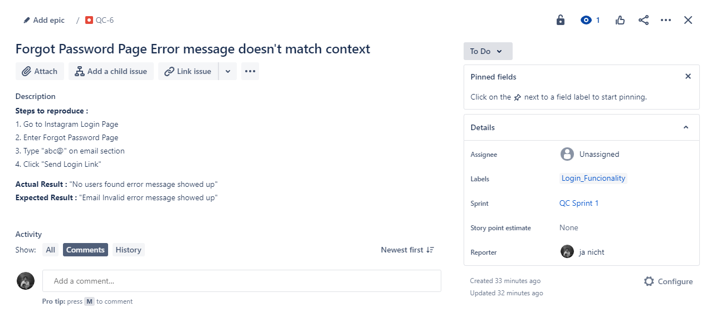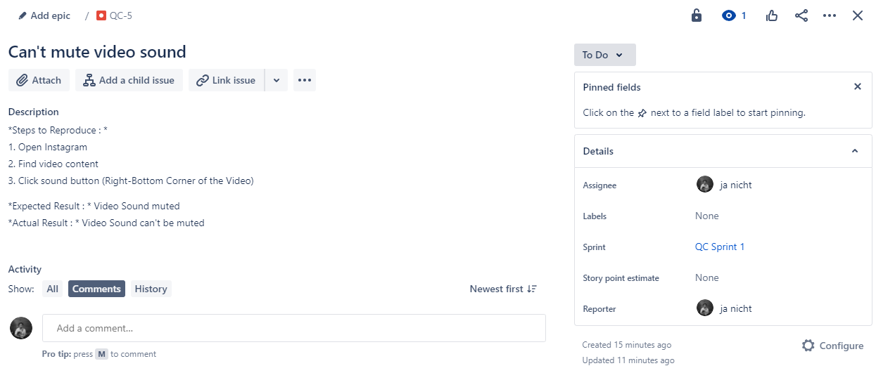

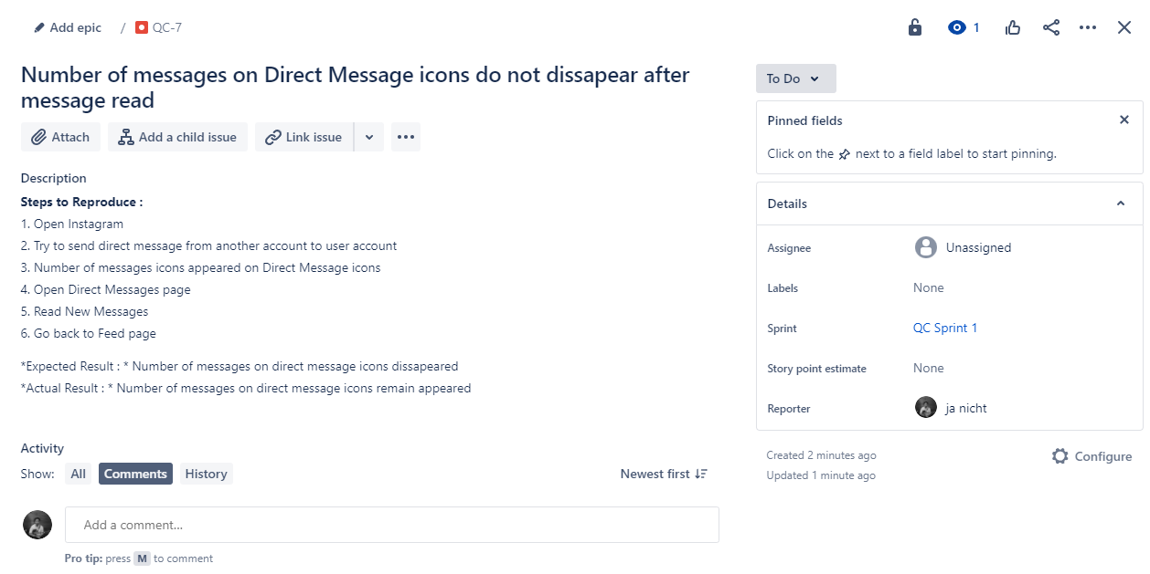

1. Bugs Issue Created on “To Do” panel

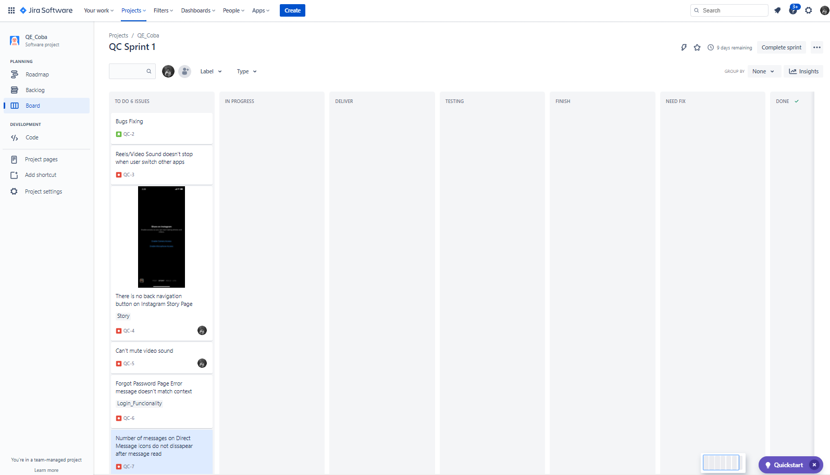

1. QA Engineer moved Issue to “Need Fix” panel

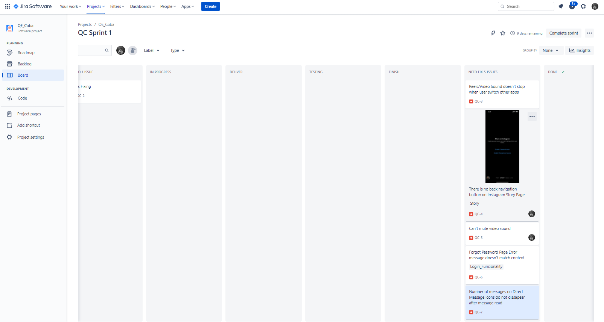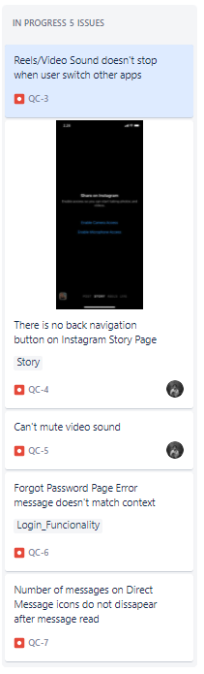

1. Developer moved issue to “In Progress” panel, fixing the bugs
2. When feature finished and ready to be tested, Developer moved Issue to “Deliver” panel

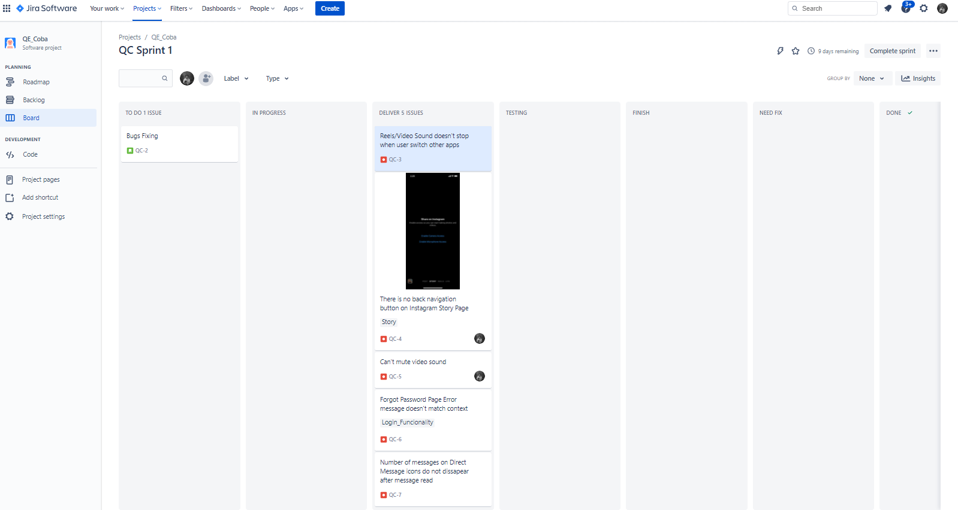

1. QA / tester test the feature

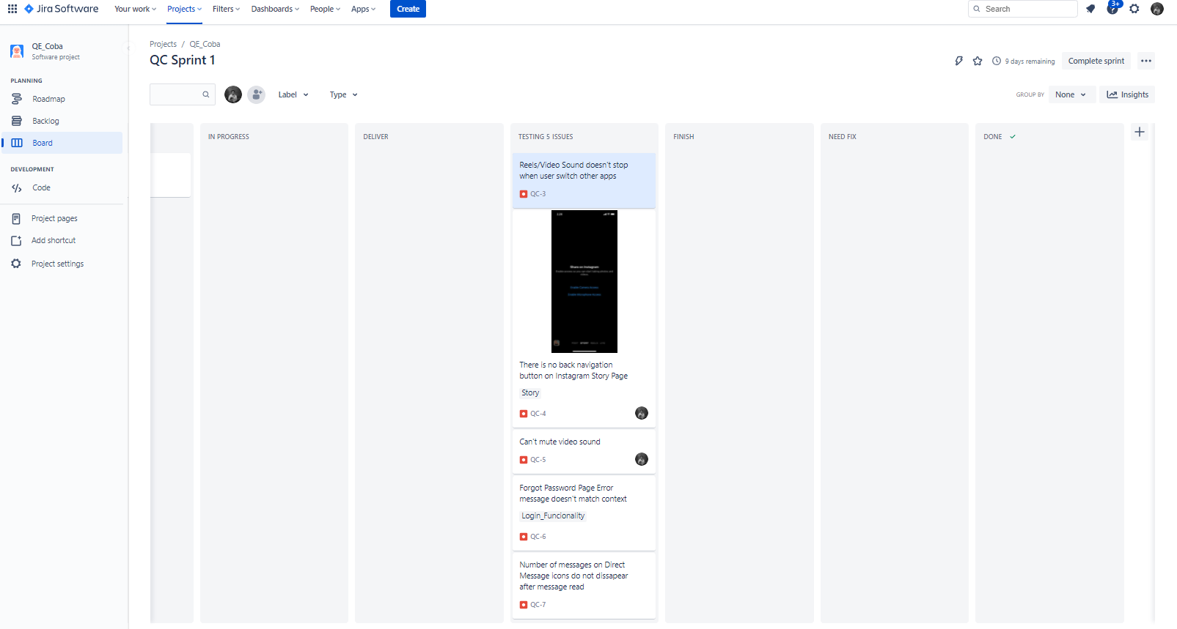

1. Bugs fixed, Issue moved to “Done” panel

